ChatGPT生成Python動畫來模擬等速率圓周運動與非等速率圓周運動

在傳統的物理教學當中，對於等速率圓周運動的學習僅止於紙上想像而已，而現在，我要教大家如何使用ChatGPT生成Python動畫，並藉此來模擬等速率圓周運動，不但如此，我還要示範ChatGPT如何對自己所寫出來的Python程式碼來執行debug之外，還可以根據你的要求在原始程式碼之上再新增你想要的程式碼。

聽到這句話的各位肝苦程式設計師們有沒有覺得此時此刻的人生終於出現了提早下班的光明與希望？話不多說，首先讓我們來看等速率圓周運動，GPT指令：

請用Python來執行以下的工作，並且Display the animation in the Jupyter Notebook from IPython.display import HTML：

1.請設計出質點進行等速率圓周運動的動畫，並且也繪製出質點的運動軌跡
2.以上內容包含程式註解在內也請轉換成英文

GPT指令生成程式碼執行結果如下所示：

import numpy as np
import matplotlib.pyplot as plt
from matplotlib.animation import FuncAnimation
from IPython.display import HTML

# Parameters
radius = 1.0 # radius of the circular path
omega = 1.0 # angular velocity (radians per second)

# Time
dt = 0.05 # time step
T = 2 * np.pi / omega # period of motion
num_frames = 100 # number of frames
t_values = np.linspace(0, T, num_frames)

# Function to compute particle position
def compute_position(t):
x = radius * np.cos(omega * t)
y = radius * np.sin(omega * t)
return x, y

# Initialize figure and axis
fig, ax = plt.subplots()
ax.set_aspect('equal')
ax.set_xlim(-1.5, 1.5)
ax.set_ylim(-1.5, 1.5)
ax.set_xlabel('x')
ax.set_ylabel('y')
ax.set_title('Uniform Circular Motion')

# Plot circular path
theta = np.linspace(0, 2*np.pi, 100)
x_circle = radius * np.cos(theta)
y_circle = radius * np.sin(theta)
ax.plot(x_circle, y_circle, linestyle='--', color='gray', label='Circular Path')

# Initialize particle
particle, = ax.plot([], [], 'bo', ms=6)

# Function to initialize the plot
def init():
particle.set_data([], [])
return particle,

# Function to update the plot
def update(frame):
x, y = compute_position(frame * dt)
particle.set_data(x, y)
return particle,

# Create animation
ani = FuncAnimation(fig, update, frames=num_frames, init_func=init, blit=True, interval=dt*1000)

# Display animation in Jupyter Notebook
HTML(ani.to_jshtml())

GPT雖然幫我們把等速率圓周運動的動畫程式碼給寫了出來，但是這個程式碼卻有個小bug：

Setting data with a non sequence type is deprecated since 3.7 and will be remove two minor releases later particle.set_data(x, y)

現在，讓我們依舊請ChatGPT來幫我們debug，GPT指令：

在下面的程式碼當中：

import numpy as np
import matplotlib.pyplot as plt
from matplotlib.animation import FuncAnimation
from IPython.display import HTML

# Parameters
radius = 1.0 # radius of the circular path
omega = 1.0 # angular velocity (radians per second)

# Time
dt = 0.05 # time step
T = 2 * np.pi / omega # period of motion
num_frames = 100 # number of frames
t_values = np.linspace(0, T, num_frames)

# Function to compute particle position
def compute_position(t):
x = radius * np.cos(omega * t)
y = radius * np.sin(omega * t)
return x, y

# Initialize figure and axis
fig, ax = plt.subplots()
ax.set_aspect('equal')
ax.set_xlim(-1.5, 1.5)
ax.set_ylim(-1.5, 1.5)
ax.set_xlabel('x')
ax.set_ylabel('y')
ax.set_title('Uniform Circular Motion')

# Plot circular path
theta = np.linspace(0, 2*np.pi, 100)
x_circle = radius * np.cos(theta)
y_circle = radius * np.sin(theta)
ax.plot(x_circle, y_circle, linestyle='--', color='gray', label='Circular Path')

# Initialize particle
particle, = ax.plot([], [], 'bo', ms=6)

# Function to initialize the plot
def init():
particle.set_data([], [])
return particle,

# Function to update the plot
def update(frame):
x, y = compute_position(frame * dt)
particle.set_data(x, y)
return particle,

# Create animation
ani = FuncAnimation(fig, update, frames=num_frames, init_func=init, blit=True, interval=dt*1000)

# Display animation in Jupyter Notebook
HTML(ani.to_jshtml())

出現下列的問題：

Setting data with a non sequence type is deprecated since 3.7 and will be remove two minor releases later particle.set_data(x, y)

請對此問題來進行修改

GPT指令生成程式碼執行結果如下所示：

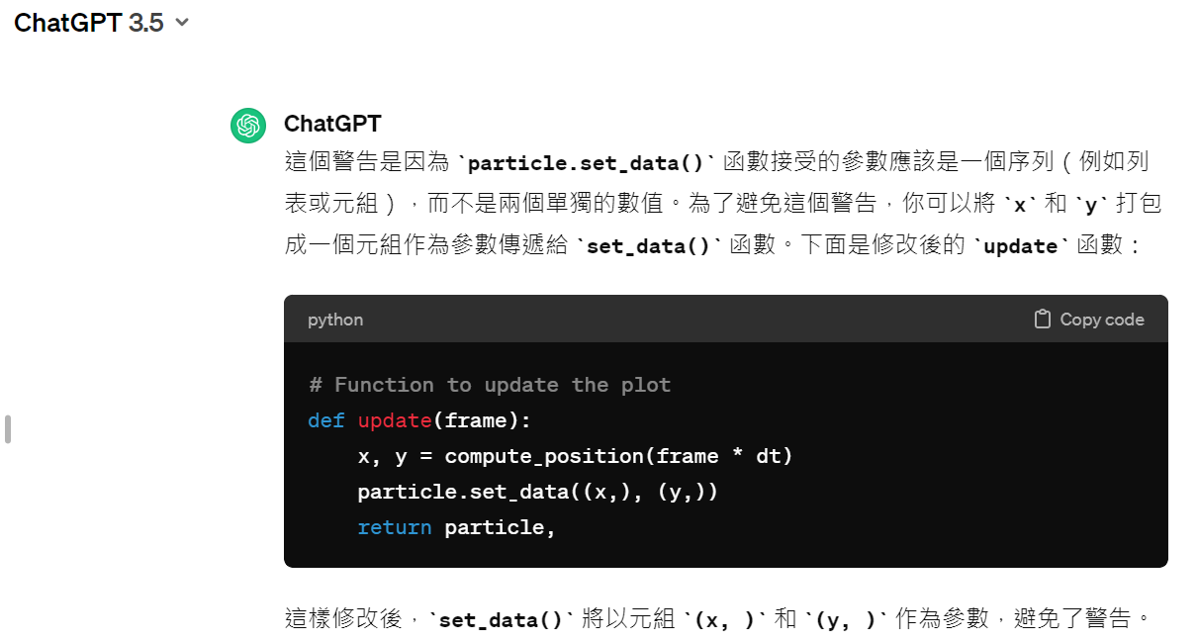

GPT很好心地幫我們把程式碼當中的bug給找了出來，不但如此，GPT還重新幫我們撰寫修改後的新程式碼，現在各位只要對上面那段新程式碼給複製貼上到原程式碼之後程式碼就可以跑了，完整程式碼如下所示：

import numpy as np
import matplotlib.pyplot as plt
from matplotlib.animation import FuncAnimation
from IPython.display import HTML

# Parameters
radius = 1.0 # radius of the circular path
omega = 1.0 # angular velocity (radians per second)

# Time
dt = 0.05 # time step
T = 2 * np.pi / omega # period of motion
num_frames = 100 # number of frames
t_values = np.linspace(0, T, num_frames)

# Function to compute particle position
def compute_position(t):
x = radius * np.cos(omega * t)
y = radius * np.sin(omega * t)
return x, y

# Initialize figure and axis
fig, ax = plt.subplots()
ax.set_aspect('equal')
ax.set_xlim(-1.5, 1.5)
ax.set_ylim(-1.5, 1.5)
ax.set_xlabel('x')
ax.set_ylabel('y')
ax.set_title('Uniform Circular Motion')

# Plot circular path
theta = np.linspace(0, 2*np.pi, 100)
x_circle = radius * np.cos(theta)
y_circle = radius * np.sin(theta)
ax.plot(x_circle, y_circle, linestyle='--', color='gray', label='Circular Path')

# Initialize particle
particle, = ax.plot([], [], 'bo', ms=6)

# Function to initialize the plot
def init():
particle.set_data([], [])
return particle,

# Function to update the plot
#def update(frame):
# x, y = compute_position(frame * dt)
# particle.set_data(x, y)
# return particle,

# Function to update the plot
def update(frame):
x, y = compute_position(frame * dt)
particle.set_data((x,), (y,))
return particle,

# Create animation
ani = FuncAnimation(fig, update, frames=num_frames, init_func=init, blit=True, interval=dt*1000)

# Display animation in Jupyter Notebook
HTML(ani.to_jshtml())

程式碼的執行結果是測試通過，bug順利消除！也就是說ChatGPT可以幫助ChatGPT自己所撰寫出來的Python程式碼來進行debug，所以如果你願意的話，你也可以把你自己所寫出來的Python程式碼請ChatGPT來幫你debug，這話聽起來是多麼天大的福音啊！

當然啦！對於上面的內容我們還不是很滿意，畢竟在整個模擬過程當中只有一顆質點在進行等速率圓周運動，所以此時如果能夠知道質點在任一時刻的運動速率的話，這樣一來整體質感會更加生動，GPT指令：

請在下面的Python程式碼當中新增一段可時時顯示出質點運動速率（speed，其單位為m/s）的Python程式碼，並把新增後的程式碼給直接插進原程式碼當中：

import numpy as np
import matplotlib.pyplot as plt
from matplotlib.animation import FuncAnimation
from IPython.display import HTML

# Parameters
radius = 1.0 # radius of the circular path
omega = 1.0 # angular velocity (radians per second)

# Time
dt = 0.05 # time step
T = 2 * np.pi / omega # period of motion
num_frames = 100 # number of frames
t_values = np.linspace(0, T, num_frames)

# Function to compute particle position
def compute_position(t):
x = radius * np.cos(omega * t)
y = radius * np.sin(omega * t)
return x, y

# Initialize figure and axis
fig, ax = plt.subplots()
ax.set_aspect('equal')
ax.set_xlim(-1.5, 1.5)
ax.set_ylim(-1.5, 1.5)
ax.set_xlabel('x')
ax.set_ylabel('y')
ax.set_title('Uniform Circular Motion')

# Plot circular path
theta = np.linspace(0, 2*np.pi, 100)
x_circle = radius * np.cos(theta)
y_circle = radius * np.sin(theta)
ax.plot(x_circle, y_circle, linestyle='--', color='gray', label='Circular Path')

# Initialize particle
particle, = ax.plot([], [], 'bo', ms=6)

# Function to initialize the plot
def init():
particle.set_data([], [])
return particle,

# Function to update the plot
#def update(frame):
# x, y = compute_position(frame * dt)
# particle.set_data(x, y)
# return particle,

# Function to update the plot
def update(frame):
x, y = compute_position(frame * dt)
particle.set_data((x,), (y,))
return particle,

# Create animation
ani = FuncAnimation(fig, update, frames=num_frames, init_func=init, blit=True, interval=dt*1000)

# Display animation in Jupyter Notebook
HTML(ani.to_jshtml())

GPT指令生成程式碼執行結果如下所示：

import numpy as np
import matplotlib.pyplot as plt
from matplotlib.animation import FuncAnimation
from IPython.display import HTML

# Parameters
radius = 1.0 # radius of the circular path
omega = 1.0 # angular velocity (radians per second)

# Time
dt = 0.05 # time step
T = 2 * np.pi / omega # period of motion
num_frames = 100 # number of frames
t_values = np.linspace(0, T, num_frames)

# Function to compute particle position
def compute_position(t):
x = radius * np.cos(omega * t)
y = radius * np.sin(omega * t)
return x, y

# Function to compute particle speed
def compute_speed(t):
speed = radius * omega # speed is constant in uniform circular motion
return speed

# Initialize figure and axis
fig, ax = plt.subplots()
ax.set_aspect('equal')
ax.set_xlim(-1.5, 1.5)
ax.set_ylim(-1.5, 1.5)
ax.set_xlabel('x')
ax.set_ylabel('y')
ax.set_title('Uniform Circular Motion')

# Plot circular path
theta = np.linspace(0, 2*np.pi, 100)
x_circle = radius * np.cos(theta)
y_circle = radius * np.sin(theta)
ax.plot(x_circle, y_circle, linestyle='--', color='gray', label='Circular Path')

# Initialize particle
particle, = ax.plot([], [], 'bo', ms=6)

# Initialize speed text
speed_text = ax.text(0.05, 0.9, '', transform=ax.transAxes)

# Function to initialize the plot
def init():
particle.set_data([], [])
speed_text.set_text('')
return particle, speed_text

# Function to update the plot
def update(frame):
x, y = compute_position(frame * dt)
particle.set_data((x,), (y,))

speed = compute_speed(frame * dt)
speed_text.set_text('Speed: {:.2f} m/s'.format(speed))

return particle, speed_text

# Create animation
ani = FuncAnimation(fig, update, frames=num_frames, init_func=init, blit=True, interval=dt*1000)

# Display animation in Jupyter Notebook
HTML(ani.to_jshtml())

以上是等速率圓周運動的情況，但在等速率圓周運動當中並沒有加速度，所以看不出質點的加速情況，在此，讓我們把上面的GPT指令給修改一下：

請把下面的Python程式碼給修改成速度越來越快的非等速率圓周運動：

import numpy as np
import matplotlib.pyplot as plt
from matplotlib.animation import FuncAnimation
from IPython.display import HTML

# Parameters
radius = 1.0 # radius of the circular path
omega = 1.0 # angular velocity (radians per second)

# Time
dt = 0.05 # time step
T = 2 * np.pi / omega # period of motion
num_frames = 100 # number of frames
t_values = np.linspace(0, T, num_frames)

# Function to compute particle position
def compute_position(t):
x = radius * np.cos(omega * t)
y = radius * np.sin(omega * t)
return x, y

# Function to compute particle speed
def compute_speed(t):
speed = radius * omega # speed is constant in uniform circular motion
return speed

# Initialize figure and axis
fig, ax = plt.subplots()
ax.set_aspect('equal')
ax.set_xlim(-1.5, 1.5)
ax.set_ylim(-1.5, 1.5)
ax.set_xlabel('x')
ax.set_ylabel('y')
ax.set_title('Uniform Circular Motion')

# Plot circular path
theta = np.linspace(0, 2*np.pi, 100)
x_circle = radius * np.cos(theta)
y_circle = radius * np.sin(theta)
ax.plot(x_circle, y_circle, linestyle='--', color='gray', label='Circular Path')

# Initialize particle
particle, = ax.plot([], [], 'bo', ms=6)

# Initialize speed text
speed_text = ax.text(0.05, 0.9, '', transform=ax.transAxes)

# Function to initialize the plot
def init():
particle.set_data([], [])
speed_text.set_text('')
return particle, speed_text

# Function to update the plot
def update(frame):
x, y = compute_position(frame * dt)
particle.set_data((x,), (y,))

speed = compute_speed(frame * dt)
speed_text.set_text('Speed: {:.2f} m/s'.format(speed))

return particle, speed_text

# Create animation
ani = FuncAnimation(fig, update, frames=num_frames, init_func=init, blit=True, interval=dt*1000)

# Display animation in Jupyter Notebook
HTML(ani.to_jshtml())

GPT指令生成程式碼執行結果如下所示：

import numpy as np
import matplotlib.pyplot as plt
from matplotlib.animation import FuncAnimation
from IPython.display import HTML

# Parameters
radius = 1.0 # radius of the circular path

# Function to compute particle position
def compute_position(t):
# Define a non-constant angular velocity
omega = 1 + 0.5 * t # angular velocity increases with time
x = radius * np.cos(omega * t)
y = radius * np.sin(omega * t)
return x, y

# Function to compute particle speed
def compute_speed(t):
# Speed is now dependent on time due to the varying angular velocity
omega = 1 + 0.5 * t # angular velocity increases with time
speed = radius * omega # speed is proportional to the angular velocity
return speed

# Initialize figure and axis
fig, ax = plt.subplots()
ax.set_aspect('equal')
ax.set_xlim(-1.5, 1.5)
ax.set_ylim(-1.5, 1.5)
ax.set_xlabel('x')
ax.set_ylabel('y')
ax.set_title('Non-Uniform Circular Motion')

# Plot circular path
theta = np.linspace(0, 2*np.pi, 100)
x_circle = radius * np.cos(theta)
y_circle = radius * np.sin(theta)
ax.plot(x_circle, y_circle, linestyle='--', color='gray', label='Circular Path')

# Initialize particle
particle, = ax.plot([], [], 'bo', ms=6)

# Initialize speed text
speed_text = ax.text(0.05, 0.9, '', transform=ax.transAxes)

# Function to initialize the plot
def init():
particle.set_data([], [])
speed_text.set_text('')
return particle, speed_text

# Function to update the plot
def update(frame):
t = frame * dt
x, y = compute_position(t)
particle.set_data((x,), (y,))

speed = compute_speed(t)
speed_text.set_text('Speed: {:.2f} m/s'.format(speed))

return particle, speed_text

# Time
dt = 0.05 # time step
T = 10 # total duration of motion
num_frames = int(T / dt) # number of frames

# Create animation
ani = FuncAnimation(fig, update, frames=num_frames, init_func=init, blit=True, interval=dt*1000)

# Display animation in Jupyter Notebook
HTML(ani.to_jshtml())
看完以上的內容之後，我相信對於每天爆肝到死的程式設計師來說，ChatGPT可說是各位的一大福音，所以只要各位善用ChatGPT，屆時每天準時下班這件事情應該不再是大家遙不可及的遠大夢想。

